It could be you
Anyone can become homeless, says Richard Hunt. He went from having a career and a loving family to being alone on the streets. Now he's rebuilding his life

Davie died the other morning. It's not the best start to the day - to open the curtains and see a body bag being loaded into the back of an anonymous van - but at the time it seemed fairly par for the course. Davie stayed in the flat above mine.
Homeless and on the streets for years, he'd assumed a kind of nowhere state, existing from one Giro to the next in a haze of disinterest, alcohol and drug abuse, and – inevitably - ill-health.
He'd been on the streets for years and was eventually taken into supported accommodation by one of the local housing associations. However, he had continued in his particular lifestyle until his body finally gave up on him.
Davie's friends would have to find somewhere else to hold their drinks parties.
I didn't really know Davie. Just the occasional encounter on the stairs, or his brief visits to our supported flat to scrounge tobacco when his money had run out. He, like me, was just another of the homeless - the amorphous mass that I've been a member of these past two-and-a-half years.
Recently I joined the management committee of Speakout, the group that campaigns on behalf of the homeless alongside The Big Issue in Scotland. My employment background is one of radio production, PR and fundraising. Five years ago I was in charge of commercial sponsorship and fundraising for one of Scotland's biggest arts companies.
For Speakout, this led naturally enough to my taking on the role of gospel-spreader.
This, in turn, introduced me to life behind the scenes at The Big Issue, and have subsequently been invited to do similar work for the magazine itself.
Five years ago, just before I was made "redundant" by my last employers, I was married with three children, a labrador, a house near Stirling, a company car and a reasonable salary.
I'd been to Oxford University and travelled a good deal of the world as a professional singer. I'd even been a presenter on BBC Radio3 and done voiceover work for Channel 4. All appeared well.
All was well.

At first I settled into the role of househusband with a great deal of satisfaction. I'd rather missed out on a lot of my daughters' very small childhood because of work commitments, so it was good to be with my youngest - a boy - and we had a great time together. At first.
Obviously, I was keen to return to work in the formal sense – and if it moved in an appropriate way I applied for it. But there came a time when there seemed to be more rejection letters than there were applications.
As he got older, my son's social and educational life began to expand, which tied me down more and more to being at particular places at particular times. I began to feel trapped.
I made bread.
I did voluntary work with the local Citizens' Advice Bureau, I walked miles with the dog. I made the ascent of various Munros with a friend in the village. I became an obsessive lawnmower.
And I took refuge in alcohol. Anything to escape the loneliness, boredom and frustration I was constantly feeling.
In short, I was clinically depressed.
Without going into too much detail, suffice it to say that things at home got worse and worse. Two years into unemployment, I was drinking a lot more than was good for me, my wife or my children. I was losing credibility - and their trust - fast.
So fast, in fact, that at the beginning of December 1996 my effectively kicked me out and I became a paid-up member of homeless. I was found "homeless accommodation" outside and then in Stirling itself
My first day in Stirling was marked by the arrival in our building of convicted paedophile. Of course, someone had leaked his whereabouts to the press, who had naturally informed local residents in order to get their reaction to presence in the area.
A very noisy and threatening demonstration began on the pavement outside, which lasted for a week, day and night, until the man was moved - this time to a secret location. By the end of the week I almost began to feel sorry him.
In Stirling I ran the risk bumping into village acquaintances and friends and having to explain myself. Worse still, on a number occasions I actually had to hide in order to avoid meeting face-to-face my elder daughter and her friends - so, I thought at the time as not to upset or embarrass her. This was hell. My drinking got worse and worse.
After six months, with the help my GP and an enlightened social worker, I was granted funding to spend six months at a rehab unit on the Kintyre peninsula. On the whole, this - when my body began to respond to a healthy diet combined with a complete absence of alcohol and being in a very beautiful place - was good.
The counselling, and the fact that I'd seen my children only once in the past year (and that on the day of Princess Diana's funeral - very jolly), wasn't. But that's another story. Six months were up. Where to now?
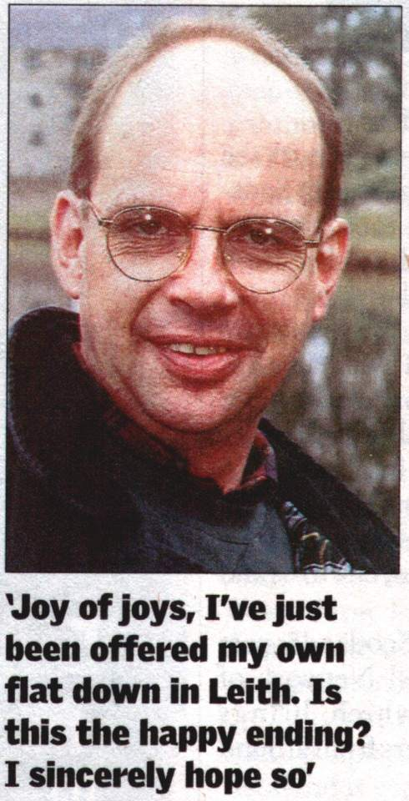

I made my roundabout way to Edinburgh. We'd lived here before, on our return to Scotland from London eight years previously. It was near enough to see my children, when and if allowed, but far enough for my wife's comfort.
I was "lucky" to get a place in a hostel in Leith. However, I was back amongst the homeless again, and a fair proportion of drinkers as well. My worst enemy was undoubtedly inactivity.
In the hostel, I had inactivity in spades. I began drinking ... in a big way.
Eventually I was referred by the owner of the hostel, which was a Christian-based organisation, to their own special rehab unit, also in Leith. I arrived just in time to "celebrate" my second homeless Christmas. Again, very jolly.
Now I'm happy to possess my own, quiet, private faith in God. What I'll never come to terms with is extreme Christianity, which to me seems almost fascistic. It might as well be spelt with a capital K.
For various reasons, the rehab unit just didn't suit. Guess what? I got fed up. I started drinking again, got found out - and was, according to the rules that I'd broken, kicked out. In effect I was on the streets. In January.
A few stays in night shelters led to a month in a hostel on the Cowgate. From there I moved to Greyfriars Hostel, which looms between the Cowgate and the Grassmarket. More inactivity. More drinking. Then the big break. Or so l thought.
I was offered a room in a shared, supported flat - the one below the late Davie. It could be worse. My nearest neighbour, with whom I share a bathroom, is a relatively amiable punk with green hair and a dog whose name rhymes with Gromit but is rather more emetic. I'm still there a year on and alcohol-free (apart from the odd unpredictable blip).
Sadly; during my time in the flat I have been threatened on a number of occasions, and also physically assaulted. As in many hostels, there is an omnipresent threat of violence, with people on short fuses and flare-ups always imminent.
I was given a black eye once, apparently for turning off a tumble dryer in the middle of the night. I hadn't.
Maybe l am a misfit. Whether it's because of my Englishness or the fact that a lot of people assume l am a member of staff; I am subject to random threats.
Another of the men in the flat took to thumping on my door in the middle of the night and casting aspersions on my sexuality.
Anyway, joy of joys, I've just been offered my own flat down in Leith. Is this the happy ending? I sincerely hope so.
In my, I admit, relatively short-term homelessness and my work for The Big Issue and Speakout, I've found that some people who become 'haves' after extended periods of being 'have-nots' go into a state of denial. "What, me? Used to be homeless? On the streets? No mate, you're thinking of someone else," and so on. It is, perhaps, understandable.
This approach, however, is definitely not for me. All my friends, most of whom have stood by me throughout it all, know exactly where I've been and what has happened.
I'm now determined to pay something back, and anything I can do to aid the cause of the homeless - if it's within my power - I'm prepared to do. Sounds evangelical, but there it is.
That said, I detest the labels "homeless" and "homelessness". They're so over-used. And, like the people in that cover-all category, they're so very hard to define.
The other day I was looking up something in the dictionary. I love looking in dictionaries. I can be in one for hours, eventually emerging with a number of highly useful words, but without the one I was first looking for. This time, serendipity led me first to "ulterior" - a word much-used but, I imagine, rarely defined.
My dictionary has "beyond what is obvious or admitted".
I then turned to ulterior's usual companion, "motive" - defined as "that which makes a person act in a particular way; inner impulse".
So, being perhaps over-simplistic, that's how I now define the homeless. Those with ulterior motives, neither obvious nor confessed. There's no such thing as "a typical homeless person". Just look at Davie and me.
So never judge a book by its cover. And always bear in mind that old National Lottery slogan: "It could be you".

